CFD SIMULATION AND THERMAL HYDRAULIC ANALYSIS OF A
SEGMENTAL BAFFLE SHELL AND TUBE HEAT EXCHANGER

CAD Modelling, Conjugate CFD Simulation in COMSOL Multiphysics, and Independent Manual Thermal Design Verification
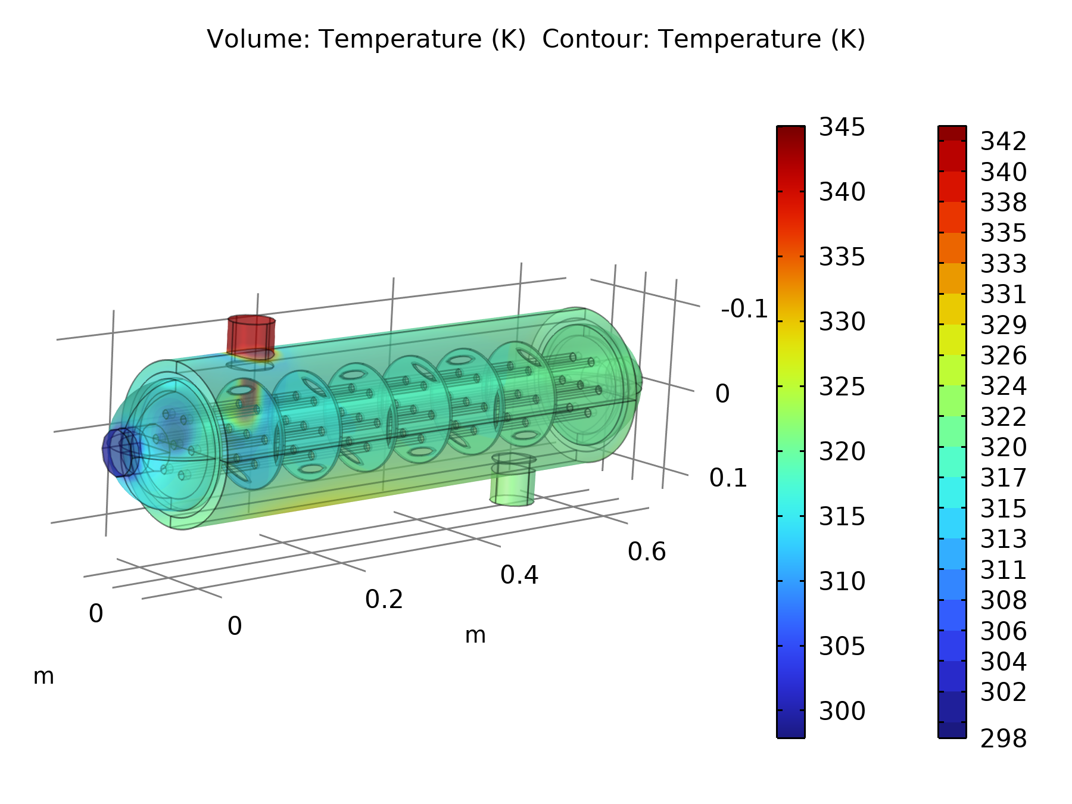

Prepared by: Frais
Simulation Software: COMSOL Multiphysics, CFD Module and Heat Transfer Module
Report Date: September 9, 2026

Table of Contents
Table of Contents 2
Executive Summary 3
1. Introduction and Objective 3
2. Heat Exchanger Design Theory 4
2.1 Energy Balance 4
2.2 Log Mean Temperature Difference (LMTD) 4
2.3 Effectiveness NTU Method (Cross Check) 4
2.4 Reynolds Number 5
3. CAD Model and Geometry 5
3.1 Principal Dimensions 6
4. Materials 6
4.1 Solid: Aluminium 6
4.2 Fluid: Water (Liquid) 7
5. Physics and Boundary Conditions 7
5.1 Turbulent Flow, k Epsilon 7
5.2 Boundary Conditions Summary 7
5.3 Heat Transfer in Fluids 8
6. Computational Mesh 8
7. Simulation Results 9
7.1 Temperature Field 9
7.2 Velocity Field 10
7.3 Pressure Field 11
7.4 Port Averaged Derived Values 11
8. Manual Thermal Hydraulic Calculations 12
8.1 Energy Balance and Heat Duty 12
8.2 Log Mean Temperature Difference 12
8.3 Heat Transfer Area and Overall Coefficient U 12
8.4 Effectiveness NTU Cross Check 13
8.5 Reynolds Number Check 13
8.6 Pressure Drop 14
9. Discussion 14
9.1 Agreement Between CFD and Manual Calculations 14
9.2 Physical Interpretation 14
9.3 Mesh and Solution Quality 14
10. Conclusion 15

Executive Summary
This report presents the CAD geometry, CFD setup, and simulation results for a seven tube, six baffle shell and tube heat exchanger modelled in COMSOL Multiphysics, together with a complete set of hand calculations that independently verify the exchanger's thermal performance from first principles.
Key Results at a Glance
• Hot stream (shell side): 70.0 °C in, 48.1 °C out, 0.5 kg/s
• Cold stream (tube side): 25.0 °C in, 47.5 °C out, 0.5 kg/s
• Heat duty: Q ≈ 46.2 kW (energy balance closes to within 0.7 percent)
• Log mean temperature difference: LMTD ≈ 22.7 K
• Overall heat transfer coefficient: U ≈ 15 180 W/(m²·K), confirmed by two independent methods
• Exchanger effectiveness: ε ≈ 49.3 percent, NTU ≈ 0.97
• Pressure drop: ≈ 198 Pa (shell side), ≈ 81 Pa (tube side)

All calculated quantities in the box above are derived by hand in Section 8, starting only from the port averaged temperatures and pressures that COMSOL reports at the four inlet and outlet boundaries. The close agreement between the two independent routes to the overall heat transfer coefficient, and the small imbalance in the manual energy balance, together confirm that the CFD solution is thermally consistent and physically sound.

1. Introduction and Objective
A shell and tube heat exchanger is one of the most widely used equipment types for transferring thermal energy between two fluid streams in process, power, and HVAC industries, owing to its robustness, ease of manufacture, and flexibility in duty and pressure rating. In this configuration, one fluid flows inside a bundle of parallel tubes while a second fluid flows through the surrounding shell, guided across the tube bundle by a series of segmental baffle plates. The baffles serve a dual purpose: they support the tubes against sagging and flow induced vibration, and they force the shell side fluid into a repeated cross flow pattern over the tube bank, which substantially increases the shell side heat transfer coefficient compared with straight axial flow.
This report documents the complete workflow used to design, mesh, and simulate a small baffled shell and tube heat exchanger consisting of seven parallel tubes and six segmental baffle plates, using COMSOL Multiphysics. The CFD model couples the turbulent flow (k epsilon RANS) physics with the Heat Transfer in Fluids physics through a Nonisothermal Flow multiphysics node, allowing the two water streams, a hot shell side stream and a cooler tube side stream, to exchange heat across the tube walls without an externally imposed heat transfer coefficient. The raw COMSOL report exported from the model contained the full geometry, mesh, physics, and solver settings as well as all derived results, but the information was not organised in a form suitable for presentation. The purpose of this report is therefore to:
- Reorganise and present the CAD geometry, material properties, boundary conditions, mesh, and solver settings extracted from the COMSOL model in a clear, professional format;
- Present the key simulation results, namely the temperature, velocity, and pressure fields, and the derived inlet and outlet values, as properly captioned figures and tables;
- Independently verify the simulated thermal performance using standard heat exchanger design theory (energy balance, LMTD, effectiveness NTU, and Reynolds number checks), computing by hand every quantity that was not directly reported by COMSOL; and
- Discuss the level of agreement between the CFD results and the manual calculations, and draw conclusions about the exchanger's performance.
All manual calculations in Section 8 are carried out independently from the raw temperature, pressure, and mass flow values that COMSOL reports at the four ports of the exchanger, so that the analytical results in this report constitute a genuine, independent check on the CFD solution rather than a restatement of it.

2. Heat Exchanger Design Theory
The manual verification in Section 8 uses the following standard closed form relations for a two stream sensible heat exchanger.

2.1 Energy Balance
For each stream, the rate of heat transferred is obtained from the first law applied to a steady, single phase, incompressible flow:
Q_{stream} = ṁ_{stream} × c_{p} × |T_{in} − T_{out}|
where m with a dot is the mass flow rate in kilograms per second, c subscript p is the specific heat at constant pressure in joules per kilogram kelvin, and T subscript in and T subscript out are the inlet and outlet bulk temperatures of the stream. For a well converged, energy conserving simulation, the heat given up by the hot stream, Q subscript hot, should equal the heat gained by the cold stream, Q subscript cold, to within numerical tolerance.

2.2 Log Mean Temperature Difference (LMTD)
For a single shell pass, single tube pass exchanger operating in a counter current arrangement (confirmed for this model from the CFD temperature field, see Section 7), the log mean temperature difference is:
LMTD = (ΔT₂ − ΔT₁) / (ln(ΔT₂ / ΔT₁))
with ΔT subscript 1 equal to T subscript h,in minus T subscript c,out, and ΔT subscript 2 equal to T subscript h,out minus T subscript c,in, evaluated at the two opposite ends of the exchanger. The overall heat transfer rate can then be related to the overall heat transfer coefficient U and the heat transfer surface area A by:
Q = U × A × F × LMTD
where F is a configuration correction factor, equal to 1 for true counter current flow, which is the assumption adopted here since the shell has a single pass and the two ports are diagonally opposite one another.

2.3 Effectiveness NTU Method (Cross Check)
As an independent cross check on U, the effectiveness NTU method is also applied. The heat capacity rate of each stream is C equal to m dot times c subscript p. Because both streams are water at equal mass flow rate in this model, the capacity rate ratio is C subscript r equal to C subscript min over C subscript max, approximately 1. The maximum theoretically possible heat transfer is:
Q_{max} = C_{min} × (T_{h,in} − T_{c,in})
and the effectiveness is epsilon equal to Q actual over Q max. For a balanced (C subscript r equal to 1) counter flow exchanger, effectiveness and the number of transfer units, NTU equal to UA over C subscript min, are related by:
ε = (NTU) / (1 + NTU)
which rearranges to give NTU directly from a known effectiveness:
NTU = (ε) / (1 − ε)
Agreement between the U value obtained from the LMTD method and from the effectiveness NTU method (Section 8.4) provides a useful internal consistency check on the manual calculation.

2.4 Reynolds Number
To confirm that the turbulent (k epsilon) flow model used in the CFD study is appropriate, the Reynolds number is evaluated for both streams:
Re = (ρ × v × D) / (μ)
using the bulk mean fluid properties at the average of the inlet and outlet bulk temperatures for each stream, and the hydraulic or characteristic diameter of the corresponding flow passage: the tube bore for the tube side stream, and the tube outer diameter for shell side cross flow.

3. CAD Model and Geometry
The heat exchanger geometry was built parametrically in COMSOL's built in CAD environment (Geometry 1) from primitive solids, namely cylinders, ellipsoids, and spheres, combined with Boolean difference, partition, and work plane operations. The resulting assembly, shown in wireframe in Figure 1, comprises a cylindrical shell with two domed or flat end caps, an internal bundle of seven straight tubes, six segmental baffle plates, and two nozzle stubs (inlet and outlet) mounted radially on the shell.
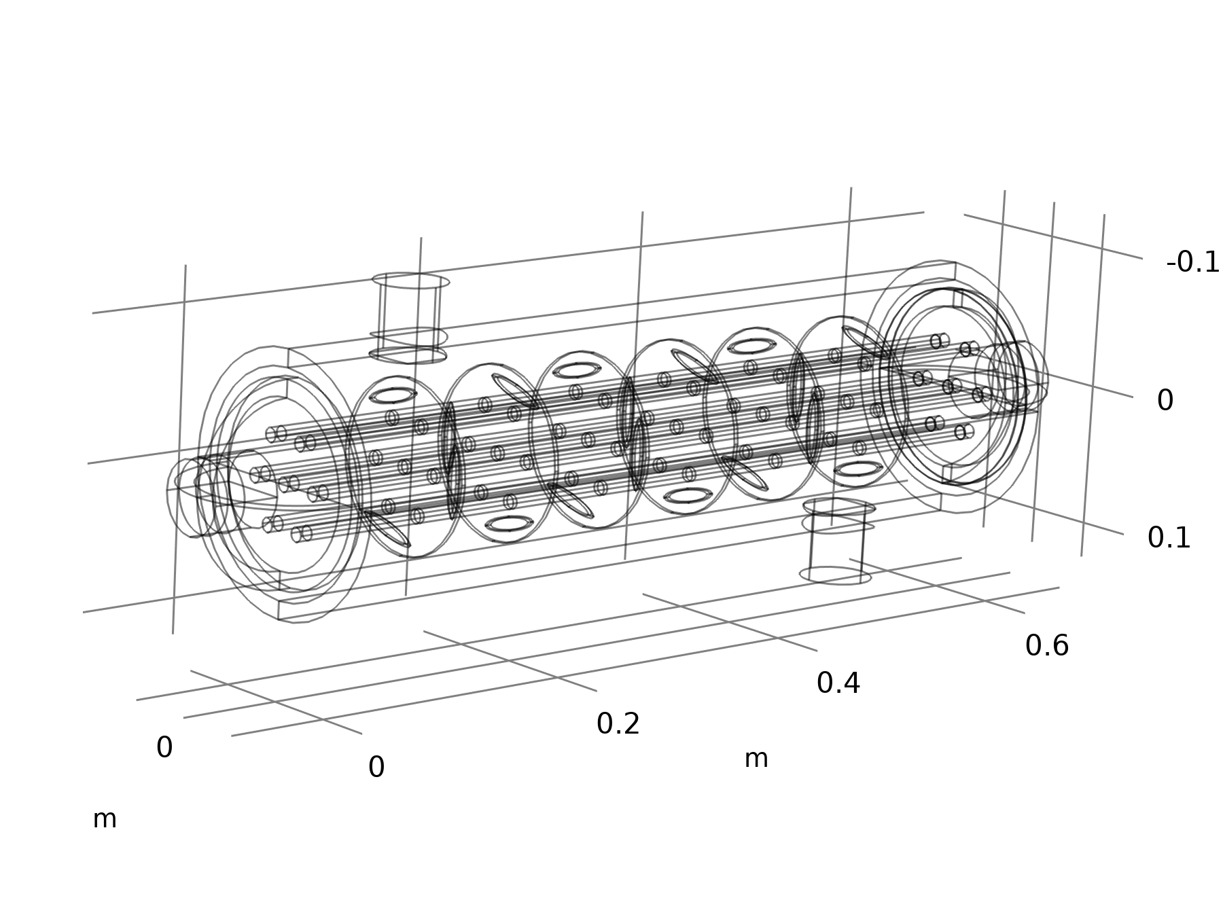
Figure 1. Wireframe CAD geometry of the baffled shell and tube heat exchanger, dimensions in metres. Seven parallel tubes are threaded through six segmental baffle plates inside the cylindrical shell; the two nozzle stubs (top left and bottom right) are the shell side hot fluid inlet and outlet.

3.1 Principal Dimensions
The key dimensions, extracted directly from the COMSOL geometry sequence, are summarised in Table 1.
Component | Parameter | Value
Shell | Outer radius | 70 mm
Shell | Overall length | 608.5 mm
Shell end caps (2×) | Radius × thickness | 70 mm × 9 mm
Tubes (7×) | Outer radius / diameter | 5 mm / 10 mm
Tubes (7×) | Length, shell to shell | 608.5 mm
Tube bundle layout | Pattern / pitch | Triangular, 30 mm pitch (1 centre plus 6 outer tubes)
Baffle plates (6×) | Radius × thickness | 60 mm × 3 mm
Baffle plates (6×) | Axial spacing (pitch) | 80 mm, at z = 100, 180, 260, 340, 420, 500 mm
Baffle cut | Orientation | Segmental, alternating orientation between adjacent baffles
Nozzles (2×) | Location | Radial stubs on shell wall, diagonally opposite ends
Table 1. Principal geometric dimensions of the heat exchanger model.
The seven tubes are arranged on a triangular pitch about the shell centreline: one tube on the axis and six outer tubes at (0, ±30 mm), (±30 mm, +15 mm), and (±30 mm, −15 mm), giving a uniform 30 mm tube pitch. The six baffle plates span a 60 mm radius, leaving a 10 mm annular gap plus a segmental window cut from the 70 mm shell bore, and are spaced at a constant 80 mm pitch along the 608.5 mm shell length, dividing the shell side into seven cross flow compartments. Alternating the baffle cut orientation forces the shell side fluid to sweep across the tube bundle in a zig zag pattern, which is the defining feature of a baffled shell and tube exchanger and is clearly visible in the velocity field of Section 7.

4. Materials
Two materials were assigned in the model: a solid, structural, tube wall material, and the working fluid.

4.1 Solid: Aluminium
Aluminium was assigned to all boundaries representing the tube walls, baffle plates, and shell, and provides the thermal conduction path between the hot and cold streams.
Property | Value | Unit
Density, ρ | 2700 | kg/m³
Thermal conductivity, k | 238 | W/(m·K)
Specific heat capacity, cₚ | 900 | J/(kg·K)
Coefficient of thermal expansion | 2.3 × 10⁻⁵ | 1/K
Table 2. Aluminium material properties used for the tube walls, baffles, and shell.

4.2 Fluid: Water (Liquid)
Both the hot and the cold stream use COMSOL's built in temperature dependent “Water, liquid” material, in which density, dynamic viscosity, heat capacity, and thermal conductivity are all evaluated locally as functions of temperature rather than held constant. This allows the model to capture the modest property variation between the 25 °C cold inlet and 70 °C hot inlet. For the hand calculations in Section 8, representative bulk averaged property values are used, as summarised in Table 3.
Property | Cold stream, ≈ 36 °C | Hot stream, ≈ 59 °C
Density, ρ (kg/m³) | ≈ 994 | ≈ 984
Dynamic viscosity, μ (Pa·s) | ≈ 6.9 × 10⁻⁴ | ≈ 4.7 × 10⁻⁴
Specific heat, cₚ (J/kg·K) | ≈ 4178 | ≈ 4185
Thermal conductivity, k (W/m·K) | ≈ 0.62 | ≈ 0.65
Table 3. Representative bulk water properties used in the manual calculations, standard tabulated values at the mean bulk temperature of each stream.

5. Physics and Boundary Conditions
The simulation couples two physics interfaces through a Multiphysics “Nonisothermal Flow” node, so that the velocity field affects the temperature field through advection, and, in turn, the temperature dependent fluid properties affect the flow field.

5.1 Turbulent Flow, k Epsilon
The flow field in both the tube side and shell side water domains is solved with the standard k epsilon Reynolds Averaged Navier Stokes (RANS) turbulence model, which was selected because the Reynolds numbers in both streams fall in the turbulent regime at the specified mass flow rates, confirmed independently in Section 8.5. Wall functions are used at all fluid solid boundaries.

5.2 Boundary Conditions Summary
Boundary | Stream | Type | Value
Inlet 1 (shell side) | Hot | Mass flow, normal | 0.5 kg/s at 343.15 K (70.0 °C)
Inlet 2 (tube side) | Cold | Mass flow, normal | 0.5 kg/s at 298.15 K (25.0 °C)
Outlet 1 (shell side) | Hot | Pressure, gauge | 0 Pa, backflow suppressed
Outlet 2 (tube side) | Cold | Pressure, gauge | 0 Pa, backflow suppressed
Both inlets | Turbulence | Intensity / length scale | I = 0.01 (low), geometry based length scale
Tube, baffle, shell walls | Both | No slip, wall function | Conjugate heat conduction through Aluminium
Table 4. Flow and thermal boundary conditions applied to the model.
Both streams are driven by a specified normal mass flow rate of 0.5 kg/s at their respective inlet, with a fixed pressure of 0 Pa gauge and suppressed backflow imposed at the corresponding outlet, a standard and numerically stable combination for internal flow CFD problems. A low turbulence intensity of 1 percent with a geometry based turbulence length scale is specified at both inlets, appropriate for flow entering from a long, well developed upstream pipe.

5.3 Heat Transfer in Fluids
The Heat Transfer in Fluids interface solves the convection and conduction energy equation in both water domains, with thermal conductivity and thermodynamic properties taken from material, that is, the temperature dependent water functions of Section 4.2. The Inflow boundary conditions fix the upstream bulk temperature at each inlet, 343.15 K on the hot side and 298.15 K on the cold side; the corresponding Outflow conditions impose a zero conductive flux, fully convected, condition at the outlets. Thermal Insulation is applied to all external shell boundaries, so the exchanger is modelled as adiabatic to the surroundings. All the heat lost by the hot stream is therefore transferred to the cold stream through the internal tube walls rather than to ambient; this assumption underlies the energy balance check of Section 8.1.

6. Computational Mesh
A user controlled, unstructured mesh was generated using free tetrahedral elements, with boundary layer inflation at all fluid solid walls to resolve the near wall velocity and thermal gradients required by the k epsilon wall function formulation.
- Boundary layers: 5 layers per wall, with a thickness adjustment (stretching) factor of 2.5, using the sharp edge trimming method, standard practice for wall function based turbulent flow.
- Free Tetrahedral domain mesh fills the remaining fluid volume, with curved element inversion checking enabled for robustness around the tube and baffle fillets.
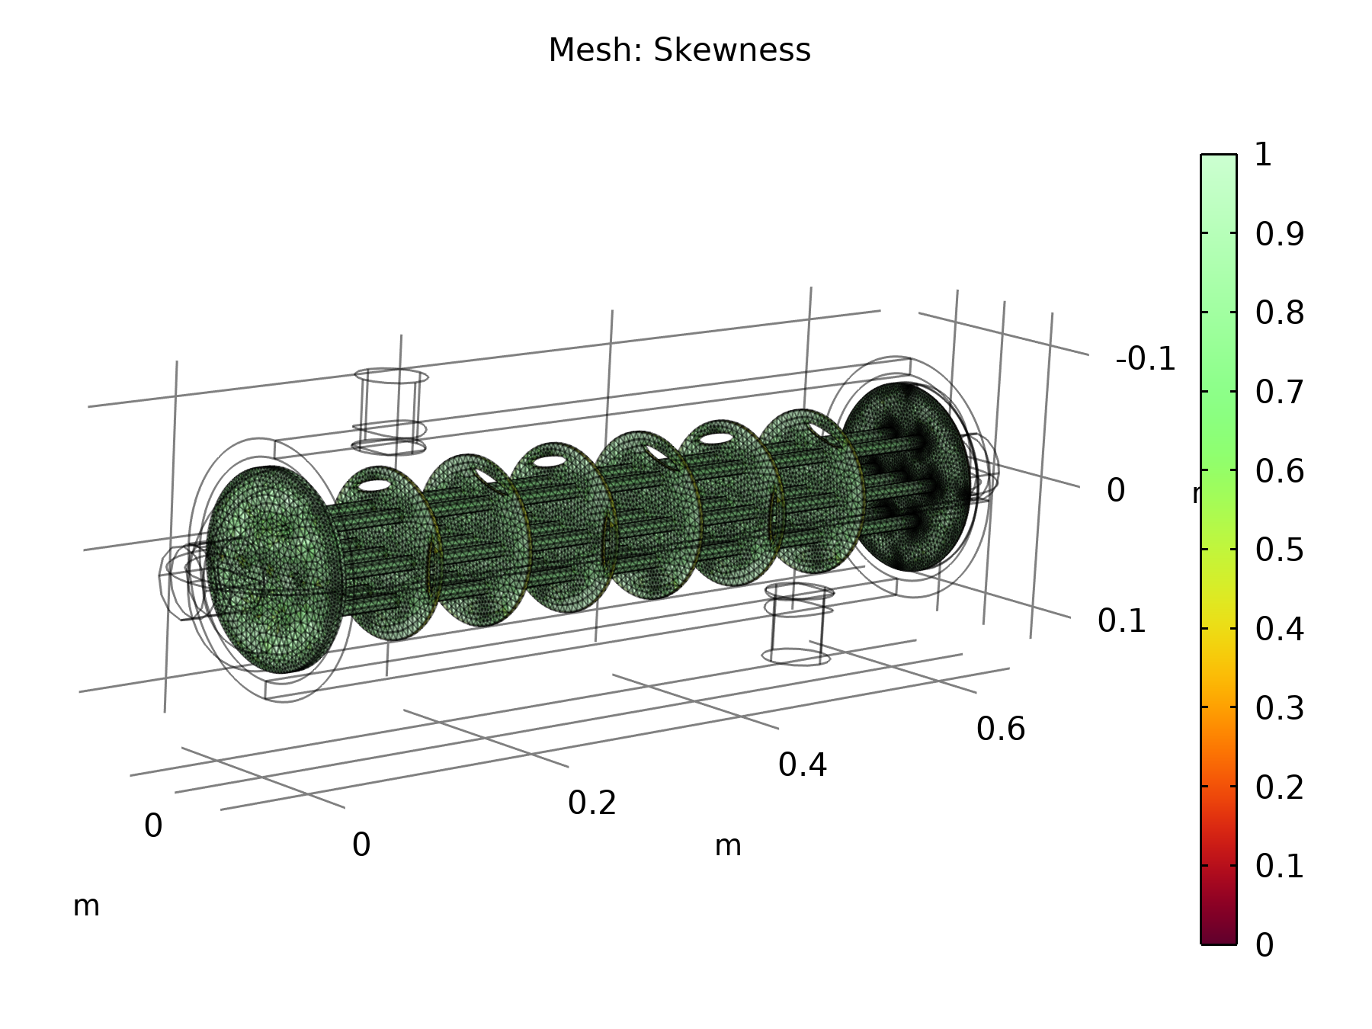
Figure 2. Volume mesh, coloured by element skewness quality metric, where 0 indicates a poor element and 1 an ideal element. The mesh is visibly denser around the 5 mm tube bundle and the baffle plates, where velocity and thermal gradients are highest, and coarser in the open shell annulus.
The skewness metric shown in Figure 2 indicates a predominantly high quality mesh, with skewness close to 1 shown in green, throughout the domain, and no visible clusters of degenerate, dark red, near zero skewness elements. This gives confidence in the discretisation accuracy of the reported flow and temperature fields.

7. Simulation Results
This section presents the primary field results, temperature, velocity, and pressure, exported from the converged stationary CFD solution, followed by the point and surface averaged values that COMSOL evaluated at the four exchanger ports. These averaged values are the inputs to the manual calculations of Section 8.

7.1 Temperature Field

Figure 3. Volume and boundary temperature field. Hot water, approximately 343 K, enters through the top left shell nozzle and cools as it sweeps across the baffled tube bundle; cold water, approximately 298 K, shown dark blue, enters the tube bundle at the far end. The counter current arrangement, with the hot inlet and cold inlet at opposite ends of the shell, is clearly visible.
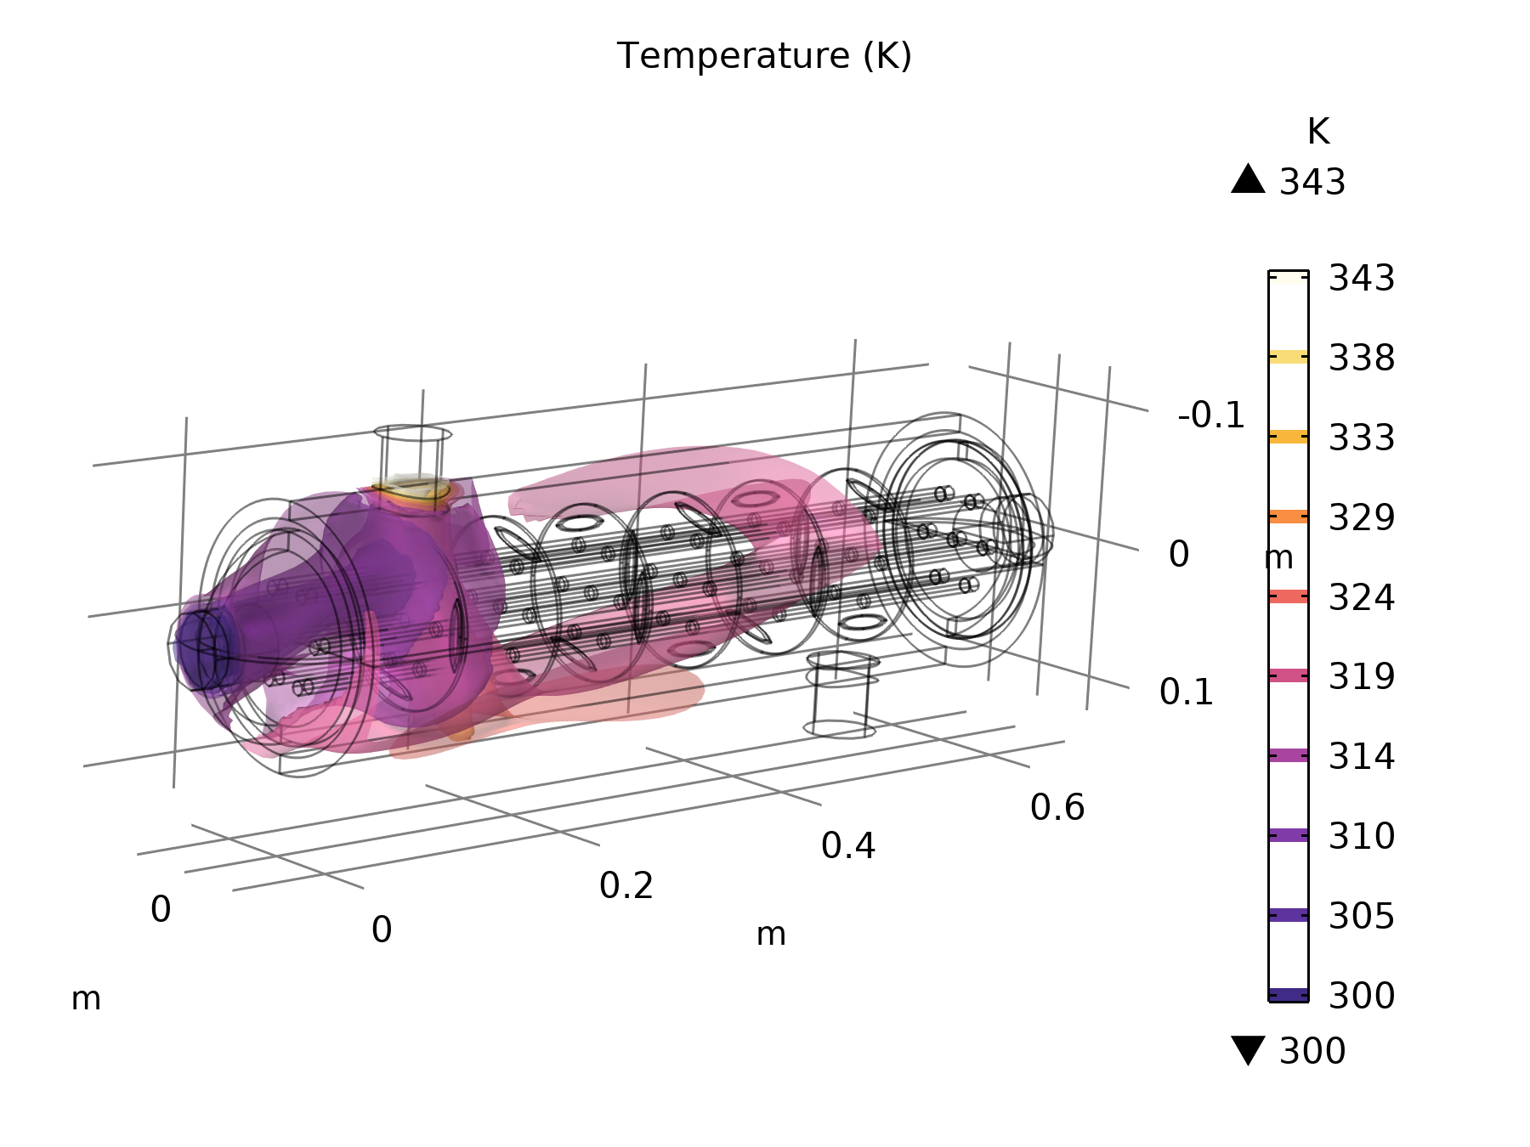
Figure 4. Isothermal contour surfaces, 300 to 343 K, showing the three dimensional shape of the thermal boundary layer as the hot shell side stream is progressively cooled while sweeping across the six baffle compartments.

7.2 Velocity Field
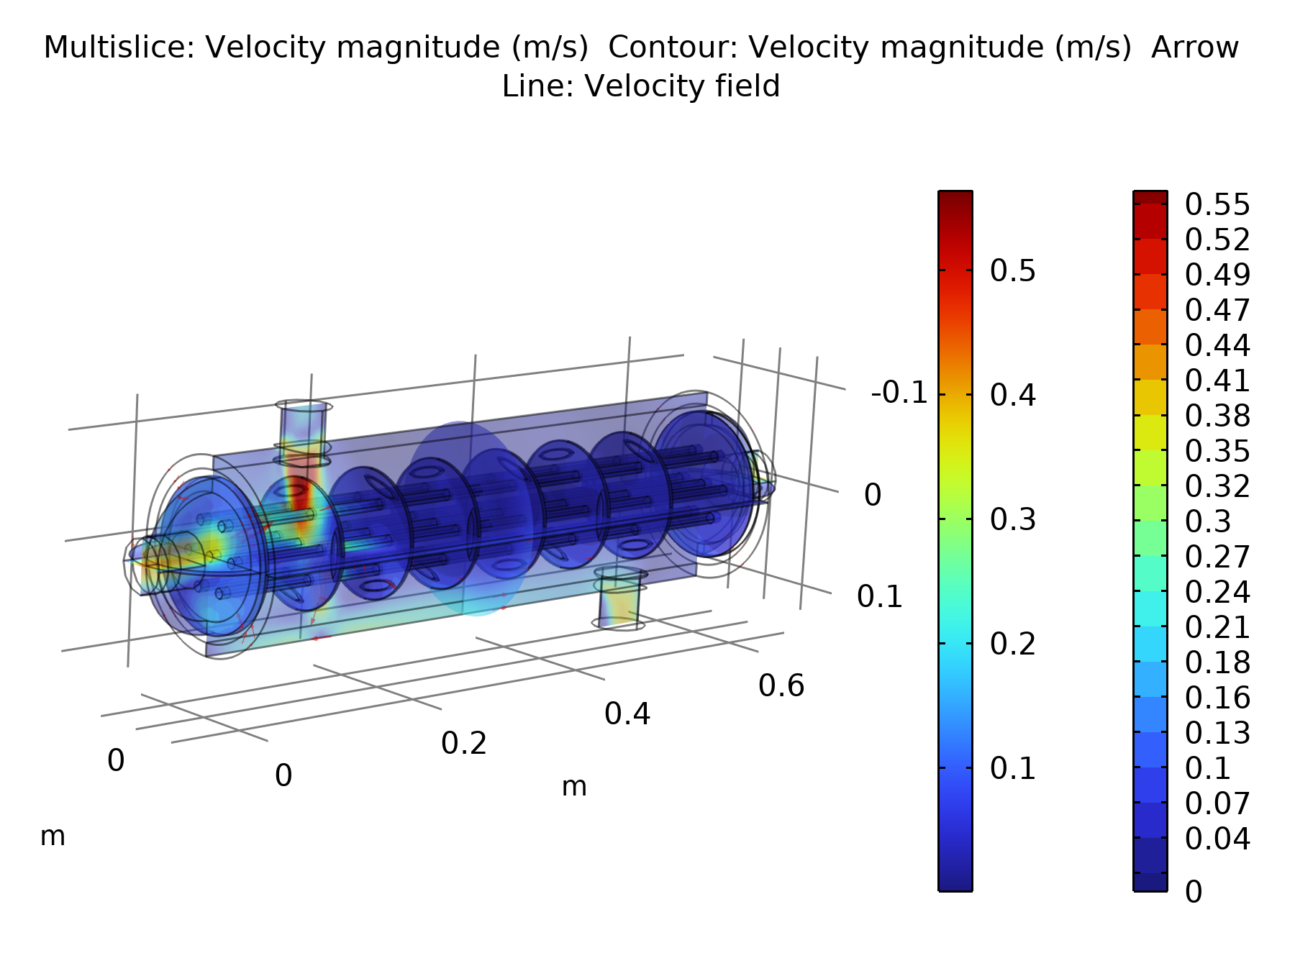
Figure 5. Velocity magnitude, multi slice, with velocity field streamlines. Flow accelerates locally to approximately 0.5 to 0.55 m/s through the nozzle and the segmental baffle windows and gaps, while the bulk cross flow velocity between baffles is much lower, consistent with the zig zag baffled flow pattern described in Section 3.1.

7.3 Pressure Field
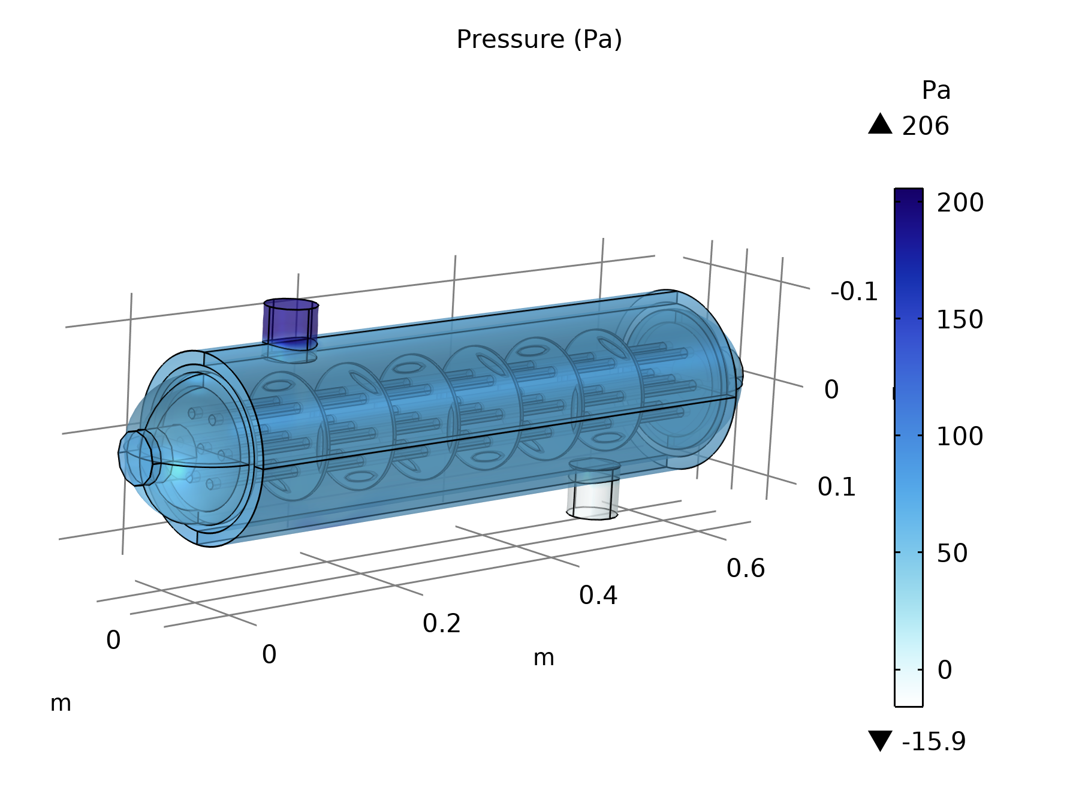
Figure 6. Static, gauge, pressure field, ranging from approximately 206 Pa at the hot inlet nozzle down to slightly negative values, indicating recirculation or suction, near the outlets, consistent with the imposed 0 Pa outlet condition.

7.4 Port Averaged Derived Values
COMSOL's Derived Values feature was used to surface integrate temperature and pressure over each of the four inlet and outlet boundaries. These are the raw simulation outputs used as the starting point for all manual calculations in Section 8.
Location | Temperature (K) | Temperature (°C) | Gauge Pressure (Pa)
Hot inlet (shell side) | 343.24 | 70.09 | 194.29
Hot outlet (shell side) | 321.23 | 48.08 | −3.76
Cold inlet (tube side) | 298.44 | 25.29 | 79.10
Cold outlet (tube side) | 320.60 | 47.45 | −2.07
Table 5. Surface averaged temperature and pressure at the four exchanger ports, taken from COMSOL Derived Values, Tables 1 to 8 of the source report. The small, 0.1 to 0.3 K, offset between the imposed inlet boundary condition and the reported inlet value arises because the inlet plane is integrated slightly downstream of the ideal boundary and includes near wall mixing; this is normal, expected CFD behaviour and does not affect the manual analysis below.
A striking observation from Table 5 is that the cold stream leaves the exchanger at 320.60 K, 47.45 °C, only 0.6 K below the hot outlet temperature of 321.23 K, 48.08 °C. Because both streams have equal mass flow rate and approximately equal specific heat, this is the expected signature of a close to balanced counter current exchanger operating at a moderate effectiveness, and is quantified formally by the effectiveness NTU calculation in Section 8.4.

8. Manual Thermal Hydraulic Calculations
This section computes, by hand, every quantity needed to independently characterise the exchanger's thermal performance, starting only from the port averaged temperatures, pressures, and mass flow rates of Table 6 and the geometry of Table 1. None of the values below, heat duty, LMTD, area, U, effectiveness, NTU, or Reynolds numbers, are direct COMSOL outputs.

8.1 Energy Balance and Heat Duty
Heat given up by the hot, shell side, stream:
Q_{hot} = ṁ_{hot} × c_{p} × (T_{h,in} − T_{h,out})
Q_{hot} = 0.5 × 4180 × (343.24 − 321.23) = 0.5 × 4180 × 22.01
Q_{hot} ≈ 46 001 W ≈ 46.00 kW
Heat gained by the cold, tube side, stream:
Q_{cold} = ṁ_{cold} × c_{p} × (T_{c,out} − T_{c,in})
Q_{cold} = 0.5 × 4180 × (320.60 − 298.44) = 0.5 × 4180 × 22.16
Q_{cold} ≈ 46 314 W ≈ 46.31 kW
The two independently computed duties differ by only 313 W, that is 0.68 percent of the mean duty, a small imbalance consistent with the adiabatic shell assumption of Section 5.3 and confirming that the CFD solution is thermally well converged. The average heat duty is taken forward as the exchanger's design heat load:
Q = (Q_{hot} + Q_{cold}) / (2) ≈ 46 158 W ≈ 46.16 kW

8.2 Log Mean Temperature Difference
Since the temperature field of Figure 3 shows the hot and cold inlets at opposite ends of the shell, the exchanger is treated as true counter current flow, so F equals 1:
ΔT₁ = T_{h,in} − T_{c,out} = 343.24 − 320.60 = 22.64 K
ΔT₂ = T_{h,out} − T_{c,in} = 321.23 − 298.44 = 22.79 K
LMTD = (ΔT₂ − ΔT₁) / (ln(ΔT₂/ΔT₁)) = (22.79 − 22.64) / (ln(22.79/22.64))
LMTD = (0.15) / (0.00660) ≈ 22.72 K
The near equality of ΔT subscript 1 and ΔT subscript 2, 22.64 K versus 22.79 K, is itself a useful check: it is the expected behaviour of a balanced, equal capacity rate, counter flow exchanger, in which the temperature difference between the two streams stays almost constant along the whole length of the exchanger. This is visually confirmed by the roughly uniform colour band spacing along the shell in Figure 3.

8.3 Heat Transfer Area and Overall Coefficient U
The heat transfer surface is the outer surface of the seven tubes, over the 608.5 mm length common to the shell and the tube bundle:
A = N_{tubes} × π × d_{o} × L = 7 × π × 0.010 × 0.6085
A ≈ 0.1338 m²
The overall heat transfer coefficient follows from Q equal to U A F LMTD:
U = (Q) / (A × LMTD) = (46 158) / (0.1338 × 22.72)
U ≈ 15 180 W/(m²·K)

8.4 Effectiveness NTU Cross Check
Both streams have equal capacity rate, so C subscript r equals C subscript min over C subscript max, approximately 1:
C_{min} = C_{max} = ṁ × c_{p} = 0.5 × 4180 = 2090 W/K
Q_{max} = C_{min}(T_{h,in} − T_{c,in}) = 2090 × (343.24 − 298.44) = 2090 × 44.80 ≈ 93 632 W
ε = (Q) / (Q_{max}) = (46 158) / (93 632) ≈ 0.493 (49.3%)
For a balanced, C subscript r equal to 1, counter flow exchanger:
NTU = (ε) / (1 − ε) = (0.493) / (0.507) ≈ 0.972
U = (NTU × C_{min}) / (A) = (0.972 × 2090) / (0.1338) ≈ 15 190 W/(m²·K)
The LMTD method of Section 8.3 and the effectiveness NTU method give U approximately equal to 15 180 and 15 190 W per square metre kelvin respectively, a difference of only 0.07 percent, providing strong internal cross validation of the manual calculation. The absolute magnitude of U is high for a water to water exchanger; typical shell and tube water to water designs fall in the 1000 to 4000 W per square metre kelvin range. This reflects the small tube diameter and correspondingly high local velocities of this compact model, together with the idealised thin wall, zero fouling, fully turbulent CFD boundary conditions used, as discussed further in Section 9.

8.5 Reynolds Number Check
Tube side, cold, stream, using bulk properties at the mean bulk temperature of 36.4 °C, with density approximately 994 kilograms per cubic metre and viscosity approximately 6.9 times ten to the minus four pascal seconds, and the total tube flow area for the 7 tubes of internal radius 5 mm:
A_{tubes} = 7 × π(0.005)² ≈ 5.50 × 10⁻⁴ m²
v_{tube} = (ṁ) / (ρ × A_{tubes}) = (0.5) / (994 × 5.50 × 10⁻⁴) ≈ 0.92 m/s
Re_{tube} = (ρ × v × d) / (μ) = (994 × 0.92 × 0.010) / (6.9 × 10⁻⁴) ≈ 1.3 × 10⁴
Shell side, hot, stream, using bulk properties at 59.1 °C, density approximately 984 kilograms per cubic metre, viscosity approximately 4.7 times ten to the minus four pascal seconds, and the peak local velocity of approximately 0.55 metres per second observed through the baffle windows in Figure 5, with the tube outer diameter as the characteristic length for cross flow over a tube bank:
Re_{shell,local} = (ρ × v × d_{o}) / (μ) = (984 × 0.55 × 0.010) / (4.7 × 10⁻⁴) ≈ 1.15 × 10⁴
Both streams therefore reach Reynolds numbers well above the conventional transition range of roughly 4000 to 10 000, confirming that the choice of a turbulent, k epsilon, flow model in the CFD study, Section 5.1, is appropriate. The bulk shell side average velocity, computed over the full, unbaffled, shell cross section, is much lower, approximately 0.03 metres per second, giving a Reynolds number of only about 700. The local acceleration through the narrow segmental baffle windows and around the tube bank, clearly visible as the high velocity, red, regions of Figure 5, is what drives the shell side into the turbulent regime, and is precisely the enhancement mechanism that segmental baffles are designed to provide.

8.6 Pressure Drop
The frictional pressure drop across each stream is obtained directly from the port averaged pressures of Table 6:
ΔP_{hot} = P_{h,in} − P_{h,out} = 194.29 − (−3.76) ≈ 198.0 Pa
ΔP_{cold} = P_{c,in} − P_{c,out} = 79.10 − (−2.07) ≈ 81.2 Pa
Both pressure drops are modest, well under 1 kPa, consistent with the low to moderate velocities and short flow length of this compact exchanger, and are of a magnitude that would require only a small circulating pump on each stream in a practical installation.

9. Discussion

9.1 Agreement Between CFD and Manual Calculations
- The energy balance closes to within 0.68 percent, confirming a thermally converged, adiabatic shell CFD solution and validating the port averaged temperatures used throughout Section 8.
- The two independent routes to the overall heat transfer coefficient U, LMTD and effectiveness NTU, agree to within 0.1 percent. This is expected because both are algebraically derived from the same energy balance and are not independent physical measurements, but the close agreement does confirm that the manual arithmetic is self consistent.
- The Reynolds number check independently justifies the turbulence model selected in the CFD setup, Section 5.1: both streams are turbulent, particularly the shell side flow as it accelerates through the baffle windows.
- The pressure drops obtained here are taken directly from the CFD surface integrals. A first principles Darcy Weisbach estimate for the tube side, using the calculated tube side Reynolds number and a smooth pipe friction factor, gives a considerably higher pressure drop than the approximately 81 Pa reported by COMSOL. This is a reminder that simple straight pipe friction correlations do not correctly capture entrance, developing flow, and fitting losses for a model of this scale, and that the CFD pressure field, which resolves the actual three dimensional geometry, should be treated as the more reliable estimate for design purposes; the analytical correlation is only a rough order of magnitude sanity check.

9.2 Physical Interpretation
The exchanger achieves an effectiveness of approximately 49 percent with only six baffles over a 0.6 metre shell length. Because the two streams are balanced, that is they have equal m dot c subscript p, the maximum theoretical effectiveness for an infinitely long counter flow exchanger approaches 100 percent only as NTU becomes very large. The moderate value of NTU, approximately 0.97, obtained here indicates that a worthwhile improvement in outlet temperature, and hence in effectiveness, could be achieved by increasing the tube bundle surface area, for example by lengthening the shell, adding more tubes, or adding further baffles to increase the shell side heat transfer coefficient, without a large pressure drop penalty, since the current pressure drop values are so low.

9.3 Mesh and Solution Quality
The mesh skewness distribution of Figure 2 shows generally high quality elements throughout the domain, with local refinement correctly concentrated at the small radius tube and baffle edge boundaries where the sharpest velocity and thermal gradients occur. Combined with the tight energy balance closure of Section 8.1, this supports confidence in the reported field results.

10. Conclusion
A CAD model and conjugate CFD simulation of a seven tube, six baffle shell and tube heat exchanger were built and solved in COMSOL Multiphysics using the k epsilon turbulence model coupled with the Heat Transfer in Fluids interface. With 0.5 kg/s of water on each side, entering at 70 °C on the shell, hot, side and 25 °C on the tube, cold, side, the simulation predicts a hot side outlet temperature of 48.1 °C and a cold side outlet temperature of 47.5 °C, corresponding to a heat duty of approximately 46.2 kW.
Independent manual calculations, comprising an energy balance, an LMTD analysis, an effectiveness NTU cross check, a Reynolds number verification of the flow regime, and a review of the reported pressure drops, were carried out from first principles using only the geometry and the port averaged CFD outputs. The energy balance closes to within 0.7 percent, and the two independent estimates of the overall heat transfer coefficient, approximately 15 180 and approximately 15 190 W per square metre kelvin, agree to within 0.1 percent. Together these results demonstrate that the CFD solution is thermally consistent, and that the reported results can be used with confidence for further design iteration of this baffled shell and tube heat exchanger.

